Standardisation Material 2025

Essential Digital Skills L1 Samples

**Presentation Software Sample A**

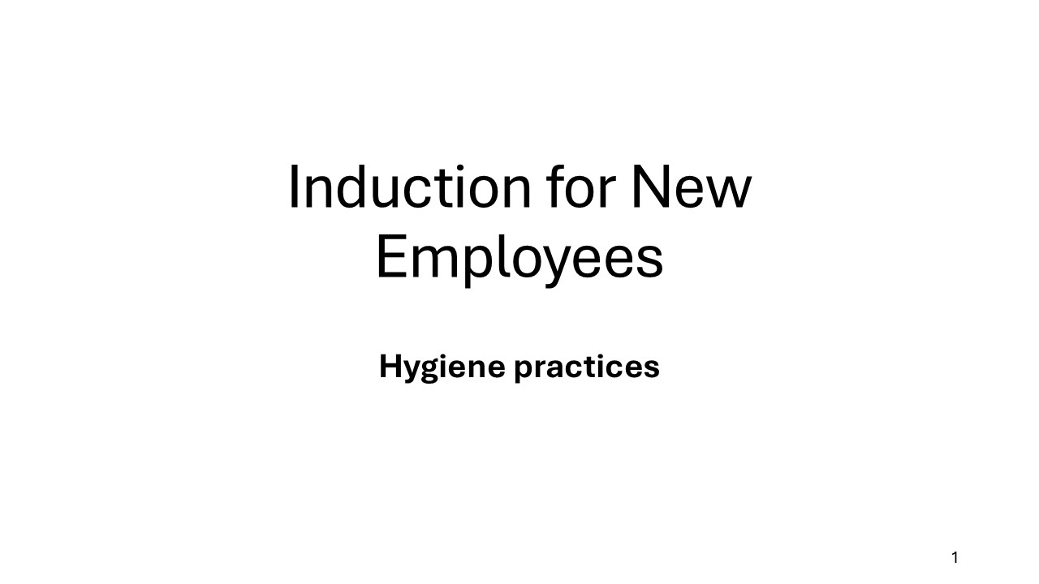

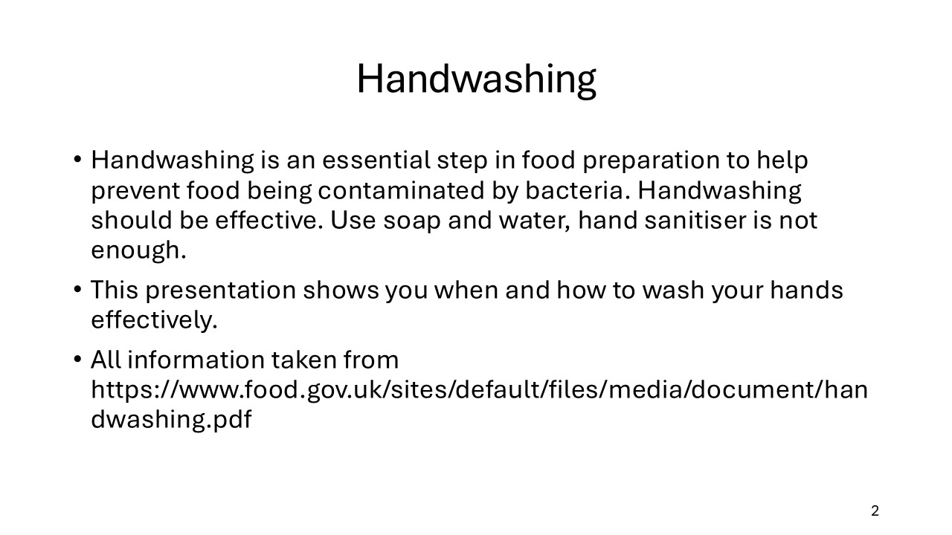

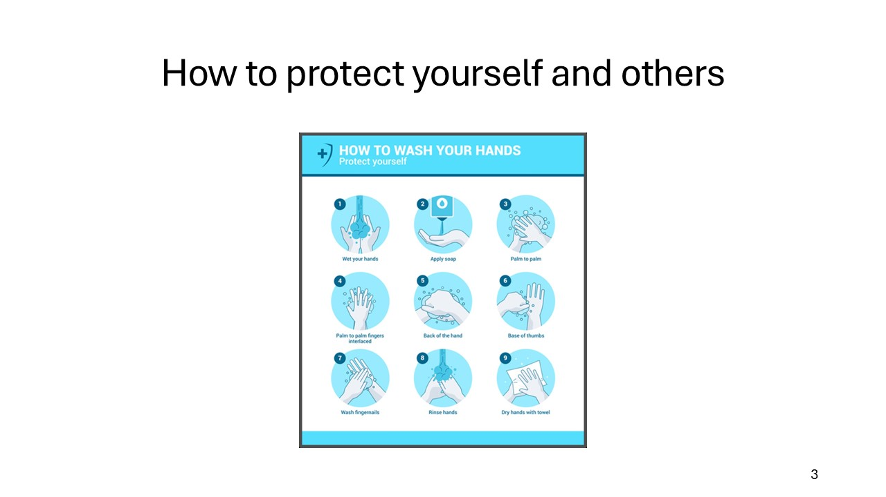

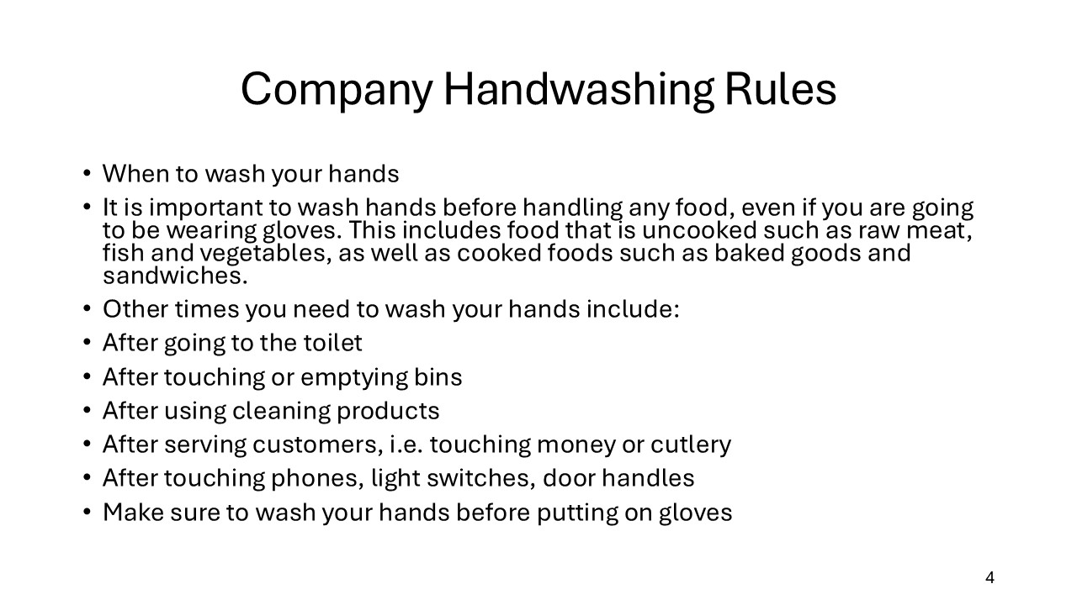

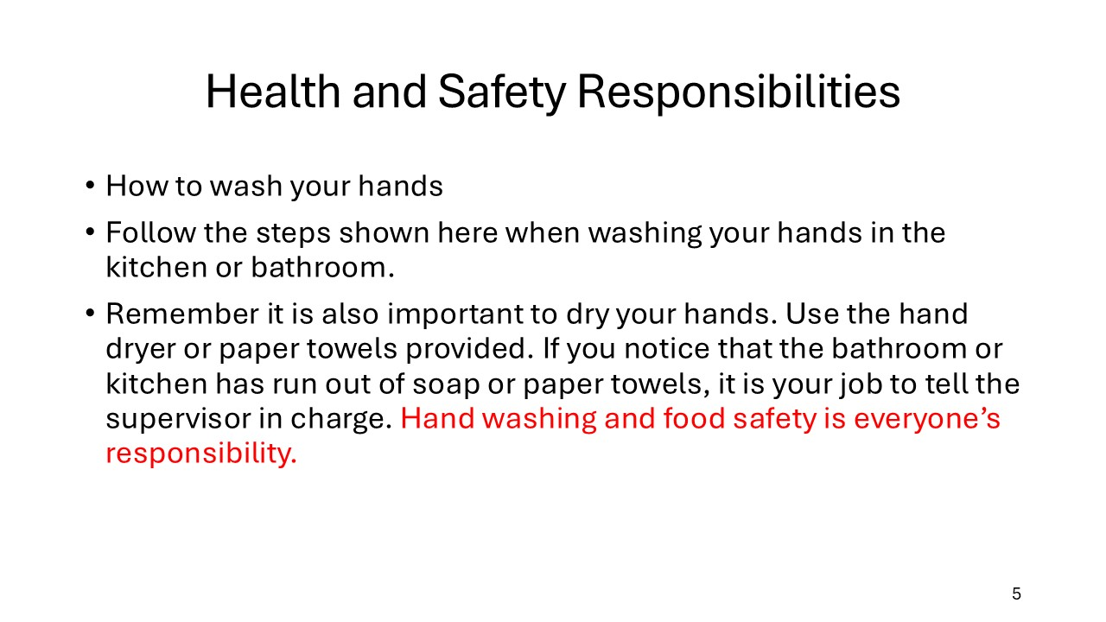

**Presentation Sample B**

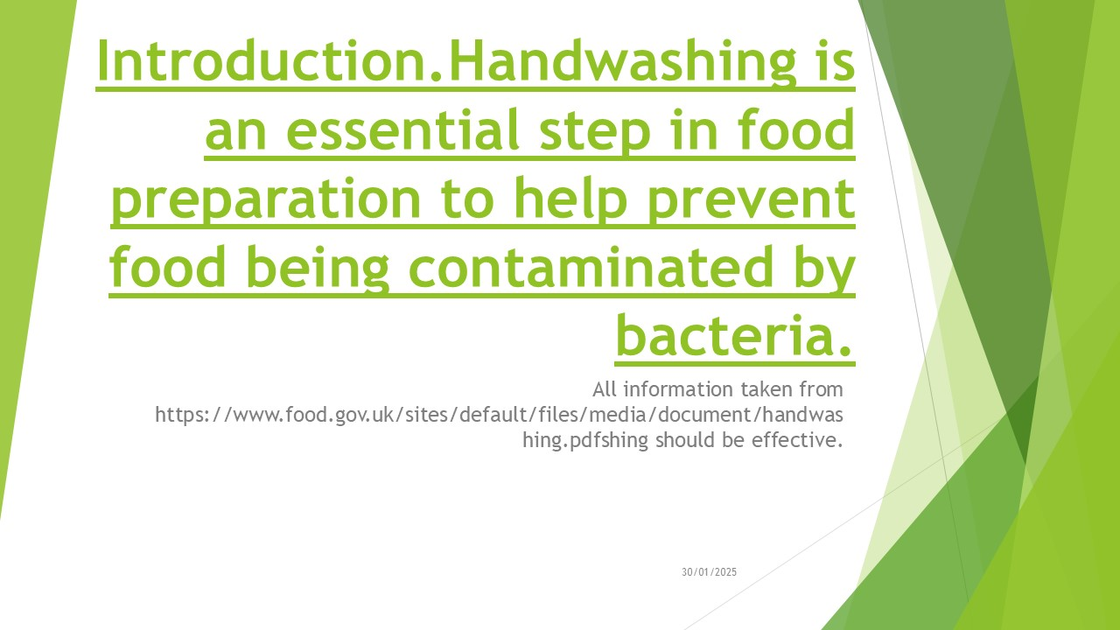

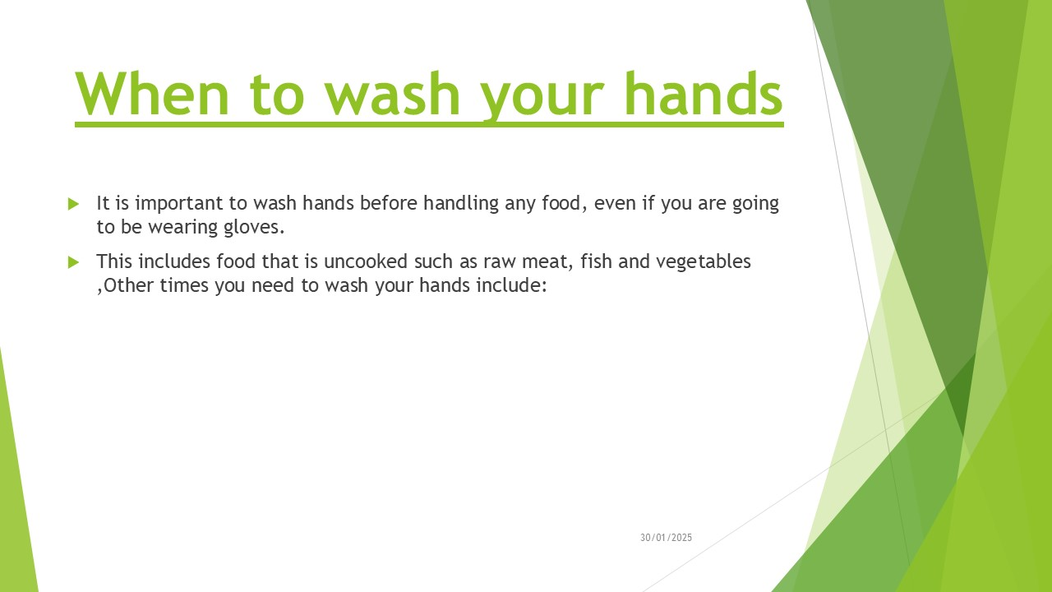

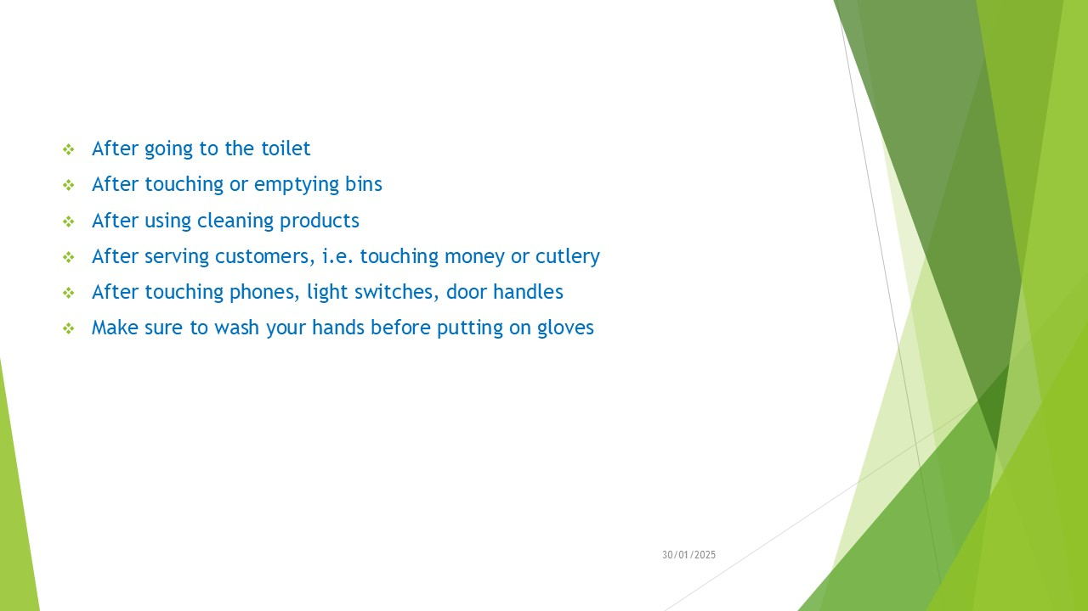

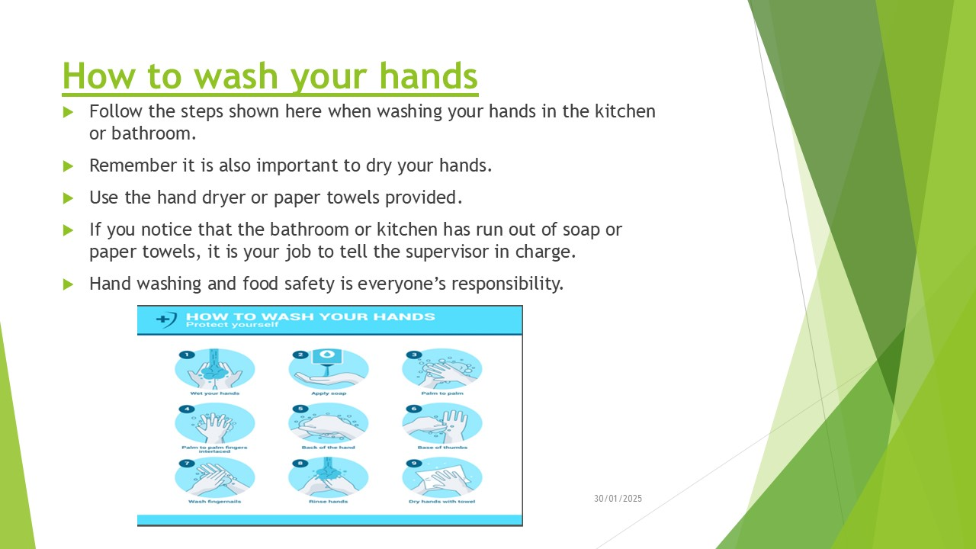

**Presentation Sample C**

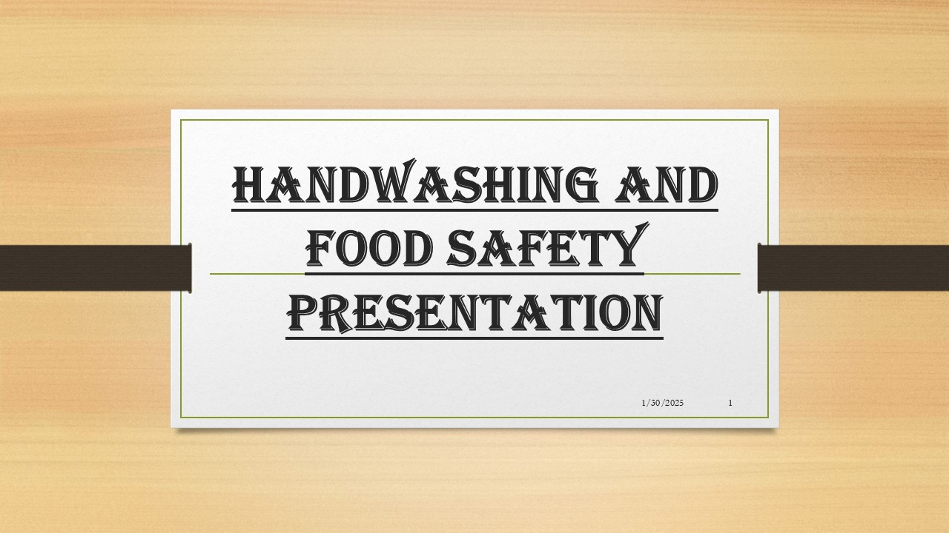

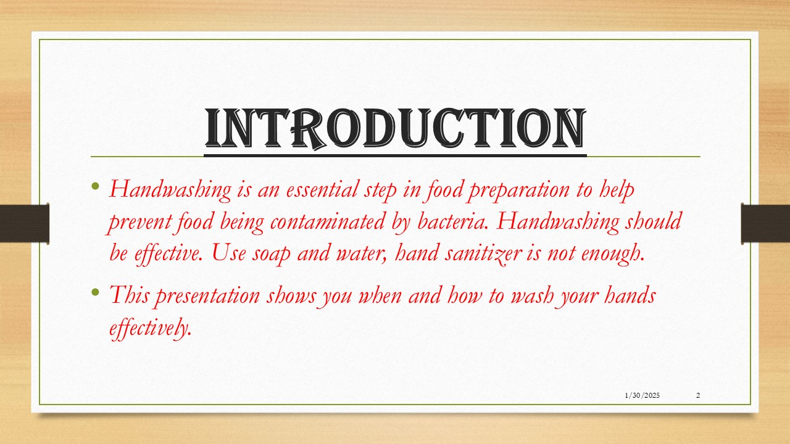

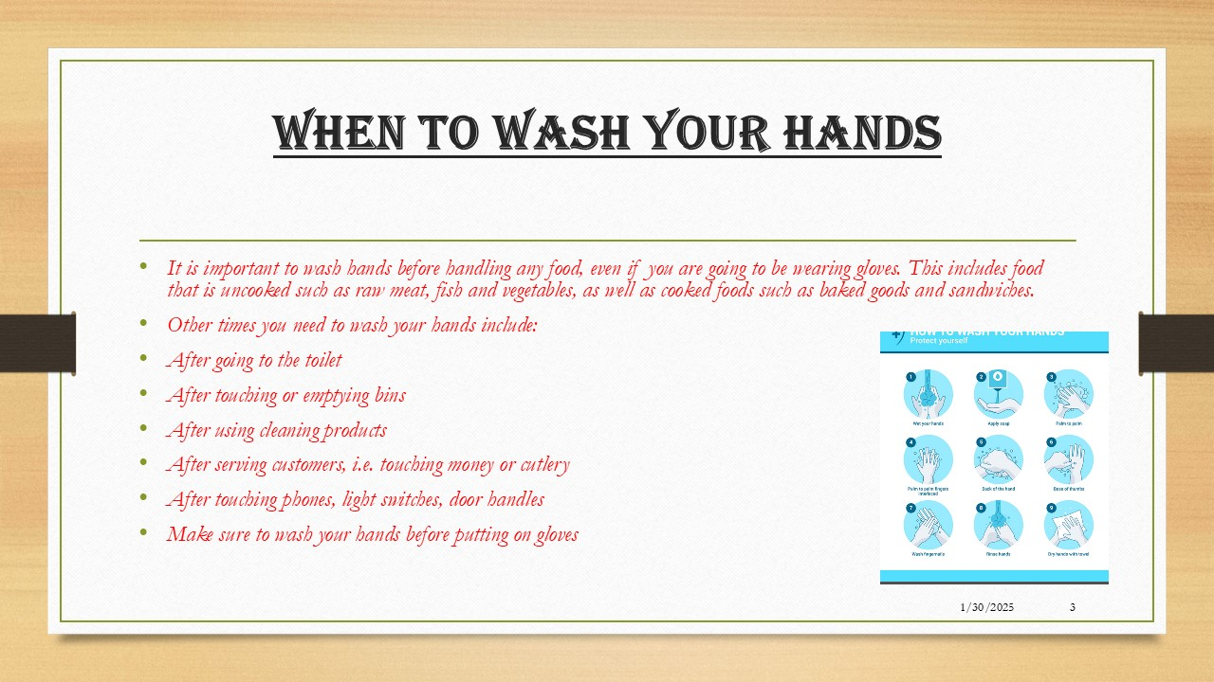

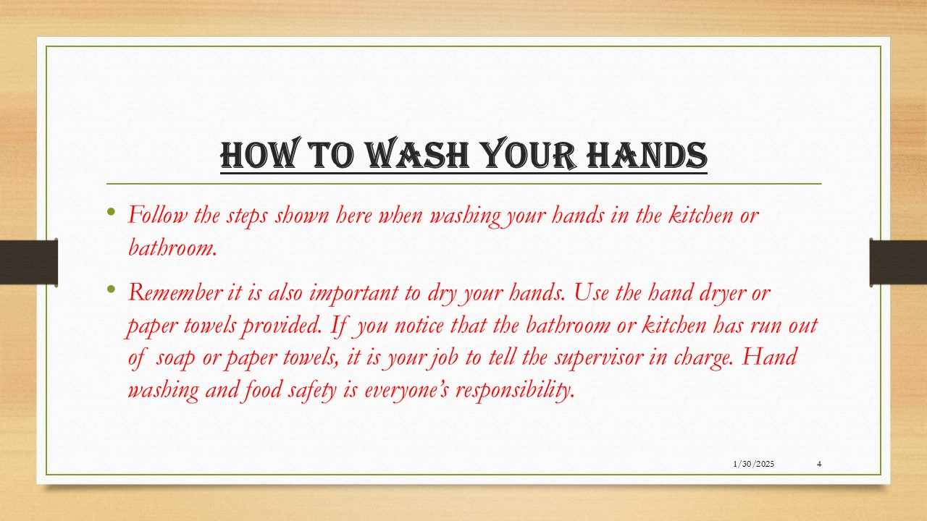

**Level 1 Word Processing   
Sample A**

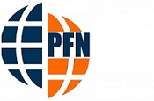

PFN Newsletter v1.0

Plastic Free Network

Let us free where we live from plastic. We live in a plastic world. It is an extraordinarily useful, versatile, cheap material but it is everywhere - in our homes, streets, parks, and beaches. If it is on our street today, then it is in our rivers tomorrow, and our beaches and oceans forever. The Plastic Free Network is tackling overuse of plastic.

Wherever you live, whether you are on shore or inland, urban or rural, high-tide or high-rise, we’re uniting communities in the fight against plastic use. There are 8,000,000 pieces of plastic pollution that find their way into the ocean every day. There are 320,000,000 tonnes of plastic generated globally every year. This is set to double by 2034.

There are 5,000 items of plastic pollution per one mile of beach in the UK. The countries in the table below produce the most plastic. Here is what you can do to help: hook up with your community and join a street, park, beach or river clean. Think global, act local.

|  |
| --- |
| Countries with most plastic production |

|  |  |
| --- | --- |
| **Country** | **Million tonnes** |
| China | 60 |
| USA | 38 |
| Germany | 14.5 |

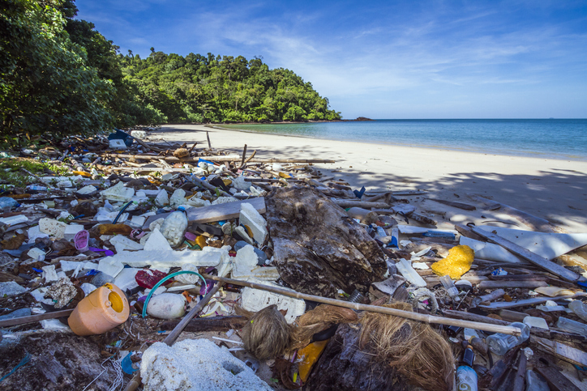

*Help Spread The Word*

**Level 1 Word Processing   
Sample B**

Plastic Free Network



Let us free where we live from plastic. We live in a plastic world. It is an extraordinarily useful, versatile, cheap material but it is everywhere - in our homes, streets, parks, and beaches. If it is on our street today, then it is in our rivers tomorrow, and our beaches and oceans forever.

The Plastic Free Network is tackling overuse of plastic. Wherever you live, whether you are on shore or inland, urban or rural, high-tide or high-rise, we’re uniting communities in the fight against plastic use. There are 8,000,000 pieces of plastic pollution that find their way into the ocean every day.

|  |  |
| --- | --- |
| Country | Million tonnes |
| China | 60 |
| USA | 38 |
| Germany | 14.5 |

There are 320,000,000 tonnes of plastic generated globally every year. This is set to double by 2034. There are 5,000 items of plastic pollution per one mile of beach in the UK.

The countries in the table below produce the most plastic.

Here is what you can do to help: hook up with your community and join a street, park, beach or river clean. Think global, act local.

**Help spread the word!**

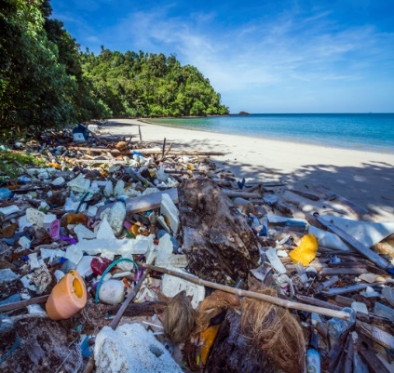



**Level 1 Word Processing   
Sample C**

**Plastic Free Network**

Let us free where we live from plastic. We live in a plastic world.

It is an extraordinarily useful, versatile, cheap material but it is everywhere - in our homes, streets, parks, and beaches.

If it is on our street today, then it is in our rivers tomorrow, and our beaches and oceans forever.

The Plastic Free Network is tackling overuse of plastic. Wherever you live, whether you are on shore or inland, urban or rural, high-tide or high-rise, we’re uniting communities in the fight against plastic use.

There are 8,000,000 pieces of plastic pollution that find their way into the ocean every day.

There are 320,000,000 tonnes of plastic generated globally every year.

This is set to double by 2034. There are 5,000 items of plastic pollution per one mile of beach in the UK.

The countries in the table below produce the most plastic.

|  |  |
| --- | --- |
| Country | Million tonnes |
| China | 60 |
| USA | 38 |
| Germany | 14 |

Here is what you can do to help: hook up with your community and join a street, park, beach or river clean. Think global, act local.

**Help spread the word!**



